ENGLISH

**Curtis Ferguson**

USA

Managing Partner of Ventech China

1. Curt is a managing partner at Ventech China. He leads Ventech China investing in Consumer Markets, focusing on the fast-growing Chinese Consumer Class.
2. Prior to that, Curt was a 38 year veteran of The Coca-Cola Company and was President of The Coca-Cola Greater China and Korea Business Unit. Curt was responsible for a US $12 billion retail business The BU operation covers more than 1.7 billion population. Across his career, he was responsible for 50+ countries
3. Curt holds a Bachelor of Science degree with majors in Finance and Management from the Indiana University Kelley School. In April 2015, he was elected to the Academy of Alumni Fellows at Indiana University and is on the Board of the Indiana University Foundation.
4. Curt was named to Forbes Top Ten Influential Business Executives in the Middle east for 7 consensus years. Recently, he was awarded as superior corporate adviser to Bao Steel Packaging - World’s largest steel maker.

“I was introduced to TEC by Linda Painan. I feel TEC plays an essential role in the ex-pat community. Hopefully, I can bring my past experience on NGO Boards, to TEC to help build a thriving net-worked ex-patriot network that not only builds great friendships but also a caring community for those less fortunate in our welcoming host country.”

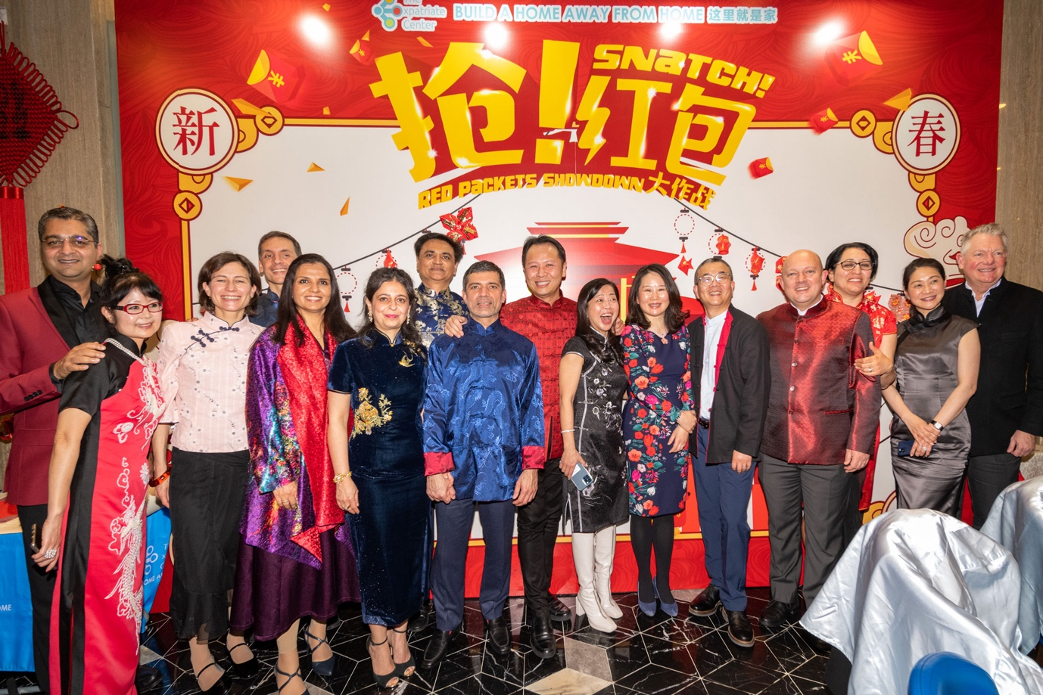

中文

**Curtis Ferguson 冯广晟**

美国

Ventech China 管理合伙人

1. 冯广晟是Ventech China的管理合伙人。 负责Ventech China在消费市场，专注于快速增长的中国消费者阶层。
2. 在此之前，冯广晟在可口可乐公司工作了30年，曾担任可口可乐大中华区和韩国业务部总裁。Curt负责120亿美元的零售业务，BU的业务覆盖超过17亿人口。
3. 他持有印第安纳大学的金融和管理学士学位。2015年4月，他被选为印第安纳大学校友研究院成员，是印第安纳大学基金会和凯利商学院院长咨询委员会的董事.
4. 他连续7年被评为福布斯中东地区十大最具影响力的CEO。 最近，他被授予宝钢包装（全球最大的钢铁制造及相关产业集团）的荣誉企业顾问。

“我很荣幸得从Linda Painan 得知了TEC。 我觉得 TEC 在外籍人士社区中发挥着至关重要的作用。 希望我能将我过去在非政府组织委员会的经验带到 TEC，以帮助建立一个蓬勃发展的社区网络，不仅可以建立良好的友谊，还可以为其他需要帮助的人建立一个关怀社区。”

